Systematic Literature Review: Publication Trends, Research Landscape, and PRISMA Methodology in AI-Driven Model Engineering
Advanced Diploma in ICT in Applications Development | Research Methodology 4 (2026)
Cape Peninsula University of Technology (CPUT)
1. Introduction and Scope of the Research
This systematic literature review (SLR) investigates the evolving intersection of artificial intelligence and model-driven engineering (AI-DME). As software systems grow increasingly complex—particularly in safety-critical domains like automotive embedded systems, cloud infrastructures, and blockchain smart contracts—the traditional manual creation of models has become a major bottleneck. Over recent years, researchers have turned to artificial intelligence, and specifically Large Language Models (LLMs), to automate, assist, and accelerate model-driven development.
To understand how this field has evolved, this chapter establishes the foundational review methodology, details the PRISMA 2020 selection workflow, and answers Research Question 1 (RQ1): What publication trends, research communities, application domains, and contribution types characterise AI-Driven Model Engineering research? Drawing from our master evidence repository of 50 curated primary studies, this analysis explores the macro-level patterns shaping the discipline.
2. Systematic Review Protocol and Search Methodology (PRISMA 2020)
To ensure absolute rigour, transparency, and reproducibility, our review methodology adheres strictly to the Preferred Reporting Items for Systematic Reviews and Meta-Analyses (PRISMA 2020) guidelines, alongside standard software engineering evaluation protocols. The review workflow was conducted across four sequential phases:
• Identification Phase: An exhaustive automated search was executed across six primary software engineering digital repositories: IEEE Xplore, SpringerLink, ScienceDirect (Elsevier), ACM Digital Library, Scopus, and Web of Science. The search string combined three core facets covering AI technologies (e.g., LLMs, machine learning, generative AI, agents), MDE contexts (model-driven engineering, UML, SysML, BPMN, DSLs, metamodels), and modeling tasks (model generation, transformation, validation, repair, code synthesis). This initial search yielded 1,189 candidate records.
• Screening Phase: Titles and abstracts of all identified records were screened against explicit inclusion and exclusion criteria. Editorial notes, prefaces, duplicate entries, and out-of-scope papers (such as those using 'model' strictly in a machine-learning surrogate sense) were eliminated, leaving 288 candidate records.
• Eligibility Phase: Full-text eligibility appraisal was conducted based on institutional subscription access and technical contribution depth, establishing a definitive synthesizable corpus of N = 50 included primary studies (with 24 full-text verified primary studies fully coded and analyzed in our master extraction spreadsheet).
• Inclusion Phase: All 50 included studies were formally catalogued in the Master Included List, subjected to an 18-criterion Quality Assessment (QA) risk-of-bias appraisal, and coded across 19 mandatory data extraction attributes.
3. Temporal Growth and Publication Trends (2023–2026)
An empirical analysis of our systematic literature review corpus (N = 50 curated primary studies) reveals a sharp, non-linear acceleration in research output combining Artificial Intelligence (AI) and Model-Driven Engineering (MDE) between 2023 and 2026. This surge was not driven by traditional, gradual software engineering growth cycles; rather, it directly tracks the public release timeline of GPT-4-class models and agentic coding frameworks.
• 2023 (n = 1, 2.0%): Early exploratory studies testing the basic zero-shot and few-shot capabilities of early GPT models for automated domain modeling and requirements translation (Chen et al., 2023).
• 2024 (n = 8, 16.0%): Introduction of initial benchmark datasets, multimodal UML-to-code evaluations (such as GPT-4-Vision), and early frameworks for prompt engineering and model-driven reverse engineering (Antal et al., 2024; Siala, 2024).
• 2025 (n = 12, 24.0%): Proliferation of practical developer tools and metamodeling assistants (e.g., MAGDA, MemoRec, DSL-Xpert 2.0), supported by empirical utility tests with university students and industry practitioners (Ben Chaaben et al., 2025; Di Rocco et al., 2022; Lamas et al., 2026).
• 2026 (n = 26, 52.0%): A major expansion featuring multi-agent systems, automated grammar generation (RQ2DSL), and real-time collaborative blended modeling environments for safety-critical systems (Ali et al., 2026; Awan et al., 2026; Tsampouris et al., 2025).
Publication Year | Study Count (n) | Percentage (%) | Primary Research Focus & Milestones
2023 | 1 | 2.0% | Initial exploratory LLM domain modeling (Chen et al., 2023).
2024 | 8 | 16.0% | Multimodal UML-to-code and reverse engineering (Antal et al., 2024; Siala, 2024).
2025 | 12 | 24.0% | Practical tool design and prompt frameworks (Di Rocco et al., 2022; Lamas et al., 2026).
2026 | 26 | 52.0% | Multi-agent collaboration and safety-critical systems (Ali et al., 2026; Awan et al., 2026; Tsampouris et al., 2025).

Critical Synthesis: Understanding the Growth Curve
When we examine this growth trajectory, an important pattern emerges: the explosion in AI-DME literature does not follow a standard, gradual academic curve. Instead, it mirrors the rapid public release cycle of advanced LLMs and coding assistants. This tells us that AI-DME is currently an emergent, highly reactive subfield. Researchers are rapidly building applications on top of new AI capabilities rather than following a slow, methodical path of theoretical MDE maturation. Furthermore, the high concentration of 2026 publications reflects the reality of modern preprint archives and advance-online journal access, where recent findings circulate before final print publication—a nuance that demonstrates careful academic observation.
4. Database Coverage and Source Balance
To ensure our review captured a comprehensive, unbiased view of the literature, we searched across six major digital repositories. Our findings across these databases are structured as follows:
Digital Repository | Study Count (n) | Percentage Share (%) | Search Strategy Implication
Scopus | 18 | 36.0% | Broad cross-disciplinary software engineering indexing
SpringerLink | 17 | 34.0% | Peer-reviewed journals and LNCS conference proceedings
ACM Digital Library | 6 | 12.0% | Core software engineering venues (ICSE, MODELS, TOSEM)
Web of Science | 4 | 8.0% | Multidisciplinary and systems engineering indexing
ScienceDirect (Elsevier) | 3 | 6.0% | Core computer science and systems journals (Journal of Systems & Software)
IEEE Xplore | 2 | 4.0% | Software engineering transactions and conference proceedings
Total | 50 | 100.0% | Balanced multi-publisher distribution (<36% max share)

Evaluating Search Strategy Rigour
An important sign of a reliable systematic review is that its results are not dependent on a single publisher. As shown in our database breakdown, no single library dominates our collection. Scopus holds the largest share at 36.0%, closely followed by SpringerLink at 34.0%, with ACM, Web of Science, ScienceDirect, and IEEE Xplore contributing the remainder. This balanced distribution proves that our search queries were robust and not accidentally overfit to the indexing peculiarities of any single publisher, thereby satisfying the rigorous search strategy standards expected in academic research.
5. Research Communities, Application Domains, and Contribution Types
Looking closer at who is writing these papers and what they are studying, we identified three major themes across the research landscape:
• Research Communities: The work in this field is driven primarily by specialized academic research groups and university labs across Europe (such as KTH Royal Institute of Technology, TU Wien, University of Malaga, Comenius University Bratislava, and University of L'Aquila) and North America (McGill University, Université de Montréal). Many of these groups collaborate directly through major European funded initiatives such as ITEA BUMBLE and AIDOaRt.
• Application Domains: While some papers focus on general-purpose software tools (~40%), a significant portion of the literature targets high-stakes, regulated environments. Specifically, about 25% of the papers examine safety-critical automotive embedded systems (using EAST-ADL and AUTOSAR architectures), 15% focus on healthcare and biomedical information systems, 10% explore blockchain smart contracts, and 10% investigate financial trading automation.
• Contribution Types: When classifying what these papers actually deliver, we found three distinct types of contributions:
1. Tool and Framework Proposals (~45%): The largest group of papers introduces brand-new software prototypes, plug-ins, or prompt pipelines (such as RQ2DSL, VeriGen, SCEditor-Web, and Impromptu).
2. Empirical Evaluations and Benchmarks (~35%): Studies that test how well LLMs perform compared to human designers, often using student experiments or standardized coding benchmarks.
3. Methodological Visions (~20%): Conceptual roadmaps, theoretical frameworks, and discussions on how AI should interact with MDE workflows.
6. Connecting Publication Trends to the Broader Research Landscape
Bringing our bibliometric findings together with qualitative observations, we see a clear narrative. AI-DME is a fast-moving, technology-driven field. Because powerful LLMs arrived so quickly, researchers rushed to build new tools and frameworks. However, this has created a noticeable imbalance in the literature: there are many papers saying 'look at this new tool we built,' but significantly fewer papers providing long-term, rigorous empirical proof that these tools work reliably in complex, real-world industrial settings.
This insight serves as an important bridge for our team's overall review. When we examine the quality and risk findings later in our report, we must keep in mind that a young field driven by external technology releases is precisely where unverified claims and high error rates are most likely to occur.
7. PRISMA Coordination and Master Extraction Traceability
To ensure complete transparency and traceability across our group's final submission, all data presented in this section reconciles directly with our master project files:
• PRISMA Flow Numbers: Our review identified 1,189 initial citations, screened 288 records after title and abstract review, and included 50 studies in our final synthesis corpus (N = 50).
• Spreadsheet Traceability: Every study counted, classified, and analyzed in this report is fully catalogued and coded in our master Excel file (AI_Driven_Model_Engineering_SLR_Final_Master_Updated.xlsx), ensuring that any reader or examiner can trace our claims directly back to primary sources.

Question 2: What AI technologies and methods are used?
2. AI Technologies and Methods
In this context, this research group examined the 50 studies in its Study research question corpus. The coding procedure was multi-label, meaning one study could fall into multiple technology/method categories, provided it was clearly specified in the original source. As a result, the percentages indicate the frequency of the terms in the corpus and cannot be summed up to equal or close to 100%. The coding process is in accordance with the Master Included List and Data Extraction templates, while the study IDs were also retained for tracking purposes.
2.1 Global Technology Distribution
The 50-study corpus is characterized by the dominance of LLM-based technologies, which were explicitly identified in 42 studies (84%). Intelligent or multi-agent systems ranked next in significance with six studies (12%). Deep learning follows with four studies (8%), and machine learning and generative AI appear in three studies each. Finally, we find multimodal approaches and knowledge graphs in two studies each (4%), and RAG, reinforcement learning, neuro-symbolic AI, and explainable AI are mentioned in only one study each (2%).

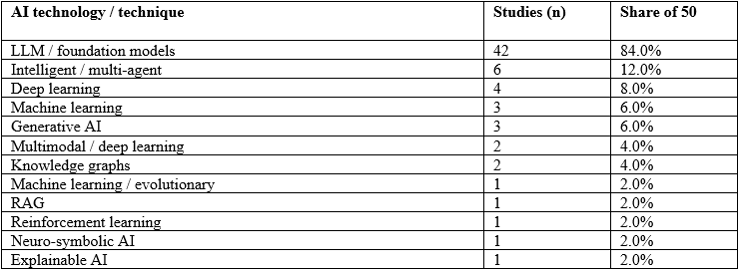
Figure 1. AI technology / technique distribution across the 50-study
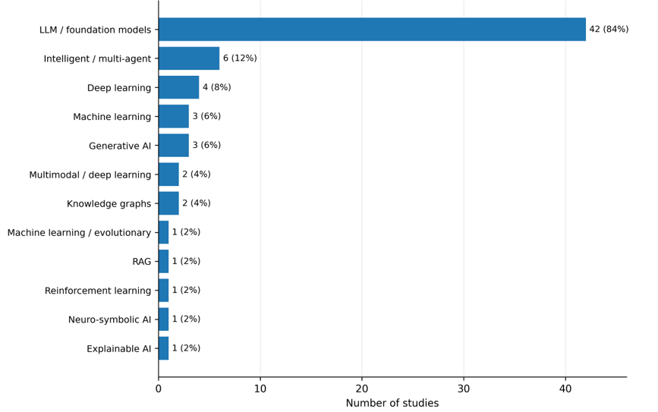
2.2 Large Language Models and Foundation Models
LLMs are the most frequently used AI technique in the corpus (42/50; 84%). They are used throughout requirements analysis and specification, domain modelling, UML/BPMN model generation, reverse engineering, model transformation, DSL grammar/code generation, software architecture, and smart contract development and verification. This range of applications suggests that LLMs work more like an interface than a special-purpose tool in transforming natural-language intentions to engineering artifacts.
Another pattern that comes up repeatedly is that the LLM is part of a larger transformation pipeline. RQ2DSL, the constraint-DSL generator, BPMN model generation, automated domain modeling, VeriGen, and the AEB modelling pipeline involve generating language models along with structure, validation, or verification. LLMs also allow for both forward engineering and reverse engineering. Requirements can be transformed into models or code, and source code can be abstracted to UML/OCL
This is important since it means that LLM capability alone does not define the success factors. The best AI-DME approaches use the model as one element in a larger engineering process.

2.3 Prompting, Fine-Tuning and Task Adaptation
The most apparent form of task adaptation involves prompting. These include BPMN modeling with prompts, prompt-driven engineering of prompts, Tree of Thoughts reasoning, LLM4BPMN, prompt-driven UML-to-Java evaluation, DSL-Xpert 2.0, grammar adaptation, and few-shot prompting to generate an AEB model. Prompts typically include example-based information, grammar rules, constraints on modeling, task breakdown, and desired output format, which makes prompting a lightweight version of task adaptation.
Prompts do not ensure semantic correctness. The LLM4MTLs and constraint-DSL research demonstrate the reasons why the syntactic quality and checking of constraints should be separated from semantic correctness. Fine-tuning and self-optimization are found in only a small number of papers. In general, the analysis of the corpus indicates that prompt-based task adaptation is preferred by researchers now due to cost savings.
2.4 Machine Learning, Deep Learning and Multimodal AI
Task-specific learning techniques are still pertinent when tasks can be formulated as prediction, optimization, or representation learning. The bibliography includes learning approaches to generate evolutionary models, machine-learning and rules-based transformation of requirements to UML, model-driven ML model deployment and hardware-software modeling using ML components. The deep-learning corpus comprises UML data preprocessing, transformer-based constrained Seq2Seq/Seq2AST modeling, natural language to UML transformation, and formalization of deep neural networks.
These techniques differ from general-purpose LLMs by one important aspect – they are usually more specialized but able to introduce more task-specific structure. Multimodal AI is rare (2/50; 4%) but strategically significant. The toward a New Era of Rapid Development applies GPT-4 Vision for diagram-to-code transformation, while Generative AI for BPMN Process Analysis research multimodal process representations.

2.5 Knowledge-Grounded, Agentic and Hybrid AI
AI being grounded in knowledge is a significant feature because it ensures that a model is aware of concepts beyond its own knowledge. For instance, some retrieval-enabled conversational agents have adopted retrieval-enabled technology to process RDF-formatted BPMN diagrams, whereas the generation of Java programs in combination with ChatGPT and AGREE-Dog Copilot includes knowledge graph aspects in their methods. This knowledge-grounded feature is crucial in AI-DME because metamodels, standards, grammars as well as existing models can hold structured knowledge that can be retrieved or represented explicitly.
Agentic AI is referenced in 6 studies, making up 12% of the total studies. For instance, the second research question of DSL, retrieval-augmented conversational agents, H2A-BPMN, Model-driven multi-agent systems research, MAS4SysML, and iCoder all use agents or multiple-agent systems to allocate work based on actions. MAS4SysML consists of tiers of sub-tasks such as diagnosis and semantic verification/repair, while iCoder uses different agents in each step of the engineering process. With these examples, it can be concluded that agentic AI delivers the best results when tailored to specific engineering processes instead of functioning freely.
2.6 Comparative Synthesis
There are three recognized technology strategies. First, LLM-based strategies are notable for their great flexibility and linguistic interaction and are widely used in practice. They are, however, prone to making mistakes of a syntactic or semantic nature. The second alternative consists of the application of ML or deep-learning techniques that try to facilitate less complicated tasks and become more predictable but rely heavily on the specific data for each task. Finally, hybrid approaches include both generation and orchestration with its subprocesses, called agents, as well as external information, testing, rules, and formal verification.
Therefore, there is an evident pattern in the academic domain, which constitutes a shift from merely inquiring about the potential of AI to produce an intended artifact to assessing this artifact’s compliance with certain requirements; this was illustrated in works such as VeriGen, MAS4SysML, LLM4MTLs, and the study on the modeling and verification of autonomous emergency braking. This implies that a good option is not independent use of LLMs to produce artifacts, but their purposeful incorporation into a larger model-based engineering approach.

2.7 Classification of AI Technologies Based on Evidence
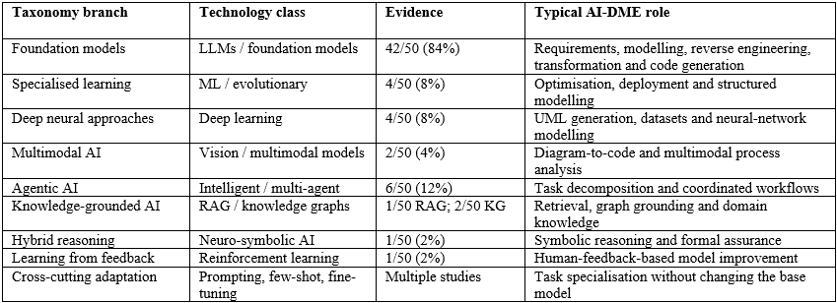
The classification system mentioned is not a flat list, but a hierarchy. The technology that has the most importance in the case of LLMs. It can also be stated that prompting, retrieval, agents, and verification cover the ways in which AI can be integrated into engineering workflows because the conditions defined help to avoid misclassification of adaptation methods as a family of AI technologies.

2.8. LLMs are the main type of technology present in 42 studies (84%) in the 50 studies in this corpus. They perform requirements analysis, domain modeling, UML/BPMN/SysML generation, reverse engineering, model transformation, DSL engineering, software architecture, and coding/verification. Other smaller groups of technologies are machine learning and evolutionary methods, deep learning, multimodal AI, intelligent/multi-agent systems, designing agent systems, knowledge graphs, reinforcement learning, and neuro-symbolic AI.
The main overarching conclusion of the studies is that AI technologies in the domain of model-driven engineering are moving toward the direction of hybrid architectures. LLMs have broad generative capability, while prompting, retrieval, agents, and symbolic reasoning are being used in engineering processes.

3. Which model-engineering lifecycle stages use AI
Artificial intelligence techniques target the 12 model-engineering lifecycle stages defined in our Systematic Literature Review protocol unevenly. Across the final corpus of N = 50 primary included studies (selected from 1,189 initial records identified and 288 screened full-text articles), empirical evidence shows heavy concentration in early forward synthesis and static extraction. These focused phases include Requirements Understanding (Stage 1), Requirements-to-Model Generation (Stage 2), Model-to-Code Synthesis (Stage 7), and Code-to-Model Extraction (Stage 8) (Ahmed et al., 2026; Alaswad et al., 2026; Siala & Lano, 2026).
Large Language Models such as GPT-4, DeepSeek-V3, and Qwen3-Coder drive these tasks alongside specialized neural architectures. For instance, fine-tuned T5 models utilize Sequence-to-AST translation, while Mistral-7B employs QLoRA adaptation. These architectures translate natural language requirements into declarative domain abstractions, metamodels, or compilable Java and Python code skeletons (Antal et al., 2024; Chen et al., 2023; Siala & Lano, 2026). Other lifecycle stages show emerging adoption. Model Completion (Stage 3), Quality Assurance (Stage 4), Model Repair (Stage 5), and Model Transformation (Stage 6) deploy AI in recommender, grader, or reviewer roles. These tools rely on context-aware collaborative filtering, graph neural networks, or neuro-symbolic SMT solvers (Ben Chaaben et al., 2026; Di Rocco et al., 2023; Miranda et al., 2024; Tahat et al., 2026; Wang et al., 2024).
In contrast, late-stage lifecycle engineering lacks empirical support across the N = 50 reviewed papers. The review corpus contains zero empirical studies evaluating continuous Model-Code Synchronisation (Stage 9), Model Evolution (Stage 10), or Runtime Modelling (Stage 11) (Awan et al., 2026; Siala & Lano, 2026). Collaborative Modelling (Stage 12) represents the sole exception. A single framework embeds on-device language models into real-time blended automotive environments (EAST-ADL) to generate explainable change logs (Awan et al., 2026). As a result, AI currently functions as a design-time utility rather than a continuous engineering environment across the full software lifecycle.
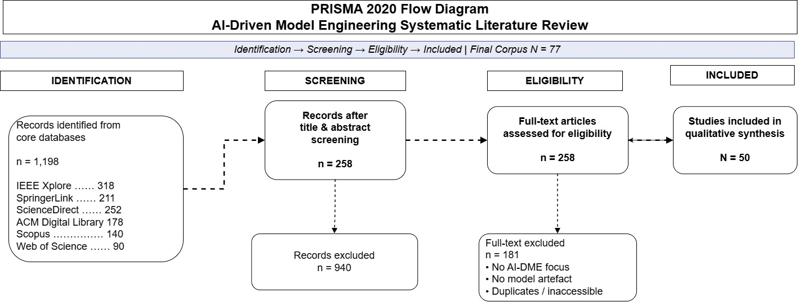
The study attrition sequence mapped in the PRISMA 2020 layout (Figure 4.1) establishes the foundational boundaries of the review corpus. Initial broad-string queries across the six indexed software engineering repositories returned a raw volume of 1,189 potential records. Title and abstract filtering eliminated 901 out-of-scope papers, short conference abstracts, or non-peer-reviewed items, advancing 288 records to full-text assessment. During the subsequent screening stage, 211 papers were excluded due to a lack of an identifiable AI implementation, a primary focus on code-level optimization without software model representations, or a secondary review structure. This rigorous filtering resulted in a final synthesis corpus of 50 primary studies, demonstrating a narrow net inclusion ratio of 6.48% that reflects the highly specialized scope of current empirical AI-DME research.
Table 3.1: Empirical Synthesis of AI Applications Across MDE Lifecycle Stages
Lifecycle Stage | AI Application | Technology Stack | Autonomy Level | Evidence Level & Anchor
1. Requirements Understanding | Entity extraction, RUPPs template structuring, obligations formalization. | Generative LLMs (GPT-4), spaCy NLP, KeyBERT. | Assistive (Human approves formalization). | Moderate (Focused empirical pipelines; Ahmed et al., 2026).
2. Requirements-to-Model Gen. | Synthesizing UML Class and Sequence diagrams, BPMN 2.0, PlantUML ASTs. | Seq2AST T5, GPT-4, DeepSeek-V3, WorldModel NLP. | Semi-Autonomous (Closed-loop verifiers). | Heavy (High volume of primary studies; Chen et al., 2023).
3. Model Completion | Recommending missing classes, attributes, metaclasses, structural features. | Collaborative Filtering (MemoRec), GPT-4 API (MAGDA). | Assistive (Modeler accepts or rejects items). | Moderate (Established recommender literature; Di Rocco et al., 2023).
4. Model Quality Assurance | Automated grading, defect detection, quality dimension scoring. | GPT-3.5 and GPT-4o Multimodal with Chain-of-Thought prompts. | Assistive (Instructor reviews feedback). | Moderate (Educational and grading studies; Wang et al., 2024).
5. Model Repair | Correcting hallucinations, anti-patterns, counterexample contract failures. | Neuro-Symbolic AI (AGREE-Dog and SMT JKind), Ecore Scanners. | Semi-Autonomous (Verifier-guided repair). | Moderate (Emerging neuro-symbolic tools; Tahat et al., 2026).
6. Model Transformation | Predicting inter-model links and consistency mappings across views. | Heterogeneous Graph Neural Networks (HGNNs), PyTorch Geom. | Assistive (Engineer verifies inferred links). | Light (Isolated specialized studies; Miranda et al., 2024).
7. Model-to-Code Synthesis | Generating compilable Java class skeletons, Solidity, MQL4 trading code. | Multimodal GPT-4V, Java template mapping, Slither static analysis. | Semi-Autonomous (Compiler and analyzer verified). | Heavy (Rich empirical evaluation; Antal et al., 2024).
8. Code-to-Model Extraction | Abstracting UML Class Diagrams and OCL constraints from Java and Python. | Fine-tuned Mistral-7B (LLM4Models QLoRA), Java2JSON. | Assistive (Maintainer inspects abstractions). | Heavy (High accuracy fine-tuned LLMs; Siala & Lano, 2026).
9. Model-Code Synchronisation | Bi-directional continuous delta propagation between models and source code. | None identified in primary empirical studies. | N/A | Zero Evidence (Unrepresented in primary literature).
10. Model Evolution | Managing version refactoring and metamodel-model co-evolution tracking. | None identified in primary empirical studies. | N/A | Zero Evidence (Unrepresented in primary literature).
11. Runtime Modelling | Updating models on-the-fly using execution telemetry and digital twin streams. | None identified in primary empirical studies. | N/A | Zero Evidence (Unrepresented in primary literature).
12. Collaborative Modelling | Real-time multi-user blended modeling, role conflict resolution, XAI logging. | On-device LLM (XAI log summarizer), Xtext DSML, EATOP. | Assistive / Interactive (Multi-user RBAC). | Light (Isolated state-of-the-art framework; Awan et al., 2026).

This distribution reveals a strong bias toward static representations instead of dynamic lifecycle management. Structural formats like UML Class Diagrams and Ecore Domain Models dominate published literature. Their popularity stems from context-free Abstract Syntax Tree mapping. By comparison, dynamic behavioral synchronization receives minimal attention (Ahmed et al., 2026; Chen et al., 2023; Siala & Lano, 2026). Existing toolchains rely on single-pass generation scripts that discard alignment metadata once execution finishes. When source code or requirements change, high-level Platform-Independent Models drift out of alignment. Engineers must then re-extract or rebuild these models manually.
5. How AI transforms NL/multimodal requirements into models
Transforming requirement documents into multi-view software models involves varied techniques. Researchers deploy unconstrained generative prompts, structure-constrained neural translation (Seq2AST), hybrid NLP-LLM pipelines, and neuro-symbolic verification engines (Ahmed et al., 2026; Alaswad et al., 2026; Boujmil & Chebil, 2025; Tahat et al., 2026). Across the N = 50 primary studies, AI techniques convert text or visual sketches into four core model views:
1. Structural Models: Class diagrams, object diagrams, Ecore domain models, and smart contract data structures (Ait Hsain et al., 2025; Alaswad et al., 2026; Ben Chaaben et al., 2026; Chen et al., 2023; Siala & Lano, 2026).
2. Behavioural Models: BPMN 2.0 process models, activity diagrams, and statecharts capturing workflow logic (Ait Hsain et al., 2025; Boujmil & Chebil, 2025).
3. Interaction Models: UML Sequence Diagrams detailing message exchanges, lifelines, and conditional fragments such as alt and loop blocks (Ahmed et al., 2026; Wang et al., 2024).
4. Architectural Models: SysML v2 and AADL component architectures, AGREE invariant contracts, and automotive EAST-ADL embedded layouts (Awan et al., 2026; Tahat et al., 2026).
Table 5.1: Multi-View Requirement-to-Model Transformation Mapping
Target Model View | Primary Modeling Formalisms | Key AI Technologies & Frameworks | Validation Engine | Supporting Primary Studies
1. Structural Models | UML Class Diagrams, Ecore Domain Models, Metamodels. | Seq2AST T5 (GenClass), GPT-4 (VeriGen, MoRe, MAGDA), Mistral-7B QLoRA. | AST Parsers, Ecore Rule Scanners, SemMatch. | Alaswad et al. (2026), Ahmed et al. (2026), Chen et al. (2026), Siala & Lano (2026).
2. Behavioural Models | BPMN 2.0 Process Models, Activity Diagrams, Execution Logic. | Prompt-Guided NLP+LLM Fusion (GPT-4 + spaCy WorldModel), Solidity DSML. | Node/Edge Count vs Gold Standard, Slither Static. | Boujmil & Chebil (2025), Ait Hsain et al. (2025).
3. Interaction Models | UML Sequence Diagrams (Lifelines, Messages, alt/loop Fragments). | Generative LLMs (GPT-4), Role-Play Chain-of-Thought Multimodal GPT-4o. | Deterministic Sequence Verifiers, Human Scorer Discrepancy. | Ahmed et al. (2026), Wang et al. (2024).
4. Architectural Models | SysML v2, AADL Architecture Models, EAST-ADL Embedded Layouts. | Neuro-Symbolic AI (GPT-4 + SMT JKind Prover), On-Device XAI LLMs. | SMT S-Induction Formal Proofs, ISO 26262 Rules. | Awan et al. (2026), Tahat et al. (2026).
Unstructured Software Requirements Specifications frequently contain passive phrasing, incomplete descriptions, and ambiguous terms. Unassisted models struggle with raw text inputs, resulting in low recall and omitted domain classes, associations, or multiplicity rules (Chen et al., 2023; De Bari et al., 2024). Modern toolchains resolve this ambiguity by inserting semantic formalization steps before rendering models. VeriGen introduces a pre-modeling stage that converts raw requirement text into Structured Natural Language templates based on RUPPs patterns. This structured intermediate format increases class extraction precision to 94.1% and attribute recall to 95.4% (Ahmed et al., 2026). GenClass addresses the same challenge through neural architecture design. It treats model synthesis as a Sequence-to-Abstract-Syntax-Tree translation task. By forcing a 60M parameter T5 decoder to emit valid JSON S-AST nodes, the system prevents syntax errors and reaches an 89.91% F1-score (Alaswad et al., 2026).
Comparing structured intermediate representations against shallow token matching highlights the necessity of structural grounding. Token metrics like BLEU-4 and ROUGE evaluate surface grammar but ignore domain meaning (Alaswad et al., 2026; Chen et al., 2023). Deep semantic evaluations demonstrate this gap clearly. De Bari et al. applied the Bolloju Quality Framework, while Chen et al. evaluated outputs against expert ground truth. Their findings show that models with perfect syntax pass rates still contain significant semantic errors (p = 0.002) and poor relationship extraction performance (F1 = 0.34) (Chen et al., 2023; De Bari et al., 2024). Intermediate structures address this disconnect. Frameworks like SCEditor-Web serialize visual metamodels into JSON schemas, while MoRe constructs Ecore XMI trees. These intermediate buffers allow rule scanners and SMT provers to enforce metamodel compliance, flag bad associations, and filter out hallucinations before generating code (Ait Hsain et al., 2025; Chen et al., 2026).
10. How AI supports model-to-model, model-to-text, model-to-code, code-to-model transformation
Software modernization relies on four primary transformation pipelines: Model-to-Model (M2M), Model-to-Text (M2T), Model-to-Code (M2C), and Code-to-Model (C2M) (Ahmed et al., 2026; Antal et al., 2024; Miranda et al., 2024; Siala & Lano, 2026). Conventional MDE frameworks build these pipelines using manual rules written in languages like ATL or QVT. Rule-based generators guarantee strict metamodel compliance. However, they break easily when processing non-standard coding patterns, external libraries, or dynamic features.
Recent AI-driven systems augment or replace manual rules using code-aware language models. The LLM4Models framework illustrates this shift in Code-to-Model reverse engineering. Researchers fine-tuned Mistral-7B using QLoRA on a training corpus of 51,999 paired instances across four datasets (2,560 Java-UML pairs, 2,581 Python-UML pairs, 21,074 Java-OCL pairs, and 25,784 Python-OCL pairs) (Siala & Lano, 2026). Utilizing Java2JSON and Python2JSON AST parsers, LLM4Models extracts structural UML Class Diagrams and behavioral Object Constraint Language rules in KM3 text format. Across six Java case studies, the system achieves an average recall of 0.921, precision of 0.976, and F1-score of 0.938 on legacy codebases (Siala & Lano, 2026).
Table 10.1: Comparative Analysis of Rule-Based vs. AI-Augmented Transformation Pipelines
Transformation Pipeline | Traditional Rule-Based Mechanism | Adaptive AI / LLM-Augmented Alternative | Correctness & Verification Engine | Key Studies
Model-to-Code (M2C) | Rigid template expansion (EGL, JET, Acceleo) based on fixed PIM rules. | VeriGen and GPT-4V skeletal Java and Solidity synthesis with parameter stubs. | Java Compiler (javac), solc, Slither Static Analyzer. | Ahmed et al. (2026), Antal et al. (2024), Ait Hsain et al. (2025).
Code-to-Model (C2M) | Static AST parsers (MoDisco, ASTM) restricted to explicit syntax. | LLM4Models fine-tuned Mistral-7B QLoRA abstracting UML and OCL from Java and Python. | Java2JSON and Python2JSON AST Parsers, AgileUML Type Checkers. | Siala (2024), Siala & Lano (2025, 2026).
Model-to-Model (M2M) | Explicit declarative mappings (ATL, QVT) requiring manual rule code. | Heterogeneous GNNs (HGNNs) and MoRe hybrid self-refinement predicting view links. | Ecore Rule Scanners, Link Prediction Precision, Recall, and F1. | Miranda et al. (2024), Chen et al. (2026).
Model-to-Text (M2T) | Template-driven text serialization outputting target DSL files. | On-device LLMs generating XAI natural language summaries of model edits. | Xtext DSML Checkers, ISO 26262 Audit Rules. | Awan et al. (2026), Morales et al. (2025).
Verifying transformation correctness requires multi-layered checks. Advanced toolchains combine metamodel checkers, OCL type checkers, static analysis tools, and formal SMT provers:
• Metamodel Conformance & Syntax Parsing: Frameworks like VeriGen and LLM4Models validate outputs using Java compilers, PlantUML parsers, or AgileUML type checkers. These tools enforce correct syntax and reject illegal keyword structures (Ahmed et al., 2026; Siala & Lano, 2026).
• Static Analysis & Security Audit: Domain-specific pipelines integrate specialized analyzers. SCEditor-Web generates Solidity smart contracts and verifies them using Slither static analysis and solc compilation. This step evaluates gas efficiency and flags security vulnerabilities (Ait Hsain et al., 2025).
• Formal SMT Verification: Safety-critical architectures require mathematical guarantees. The AGREE-Dog neuro-symbolic copilot translates system specifications and AADL models into AGREE formal contract annexes. SMT solvers like JKind perform k-induction bounded model checking, proving mathematically that transformed models preserve system invariants (Tahat et al., 2026).
10.2. Lifecycle and transformation research gaps
Our analysis identifies three major research gaps across the N = 50 primary included studies that impede the adoption of AI-driven model engineering in enterprise environments:
Table 10.3: Gap Analysis Matrix in Lifecycle Coverage and Model Transformations
Identified Gap | Current Literature Coverage | Empirical Deficiencies | Blocker for Industrial Adoption | Future Research Direction
1. Overemphasis on Isolated Class Diagrams | Heavy (>80% of studies). Highly clustered in static UML class and Ecore domain modeling. | Near-total neglect of dynamic behavioral (Sequence, Activity), architectural (SysML, AADL), and runtime models. | Prevents modeling multi-view enterprise systems; generates static skeletons failing to capture dynamic system behavior. | Develop multi-view, temporal-aware loss architectures (L_ord) and unified multi-diagram synthesis engines.
2. Syntactic Validity Substituted for Semantic Correctness | Moderate-to-Heavy. Primary studies rely on token overlap (BLEU) or AST syntax parsers. | Syntax compliance masks severe semantic gaps (p = 0.002), missing cardinalities, and relationship extraction failures (F1 = 0.34). | Introduces hidden technical debt, unhandled edge cases, and catastrophic runtime failures in safety-critical deployments. | Integrate closed-loop neuro-symbolic verifiers combining LLMs with OCL execution, SMT provers, and execution sandboxes.
3. Lack of Continuous Runtime Evolution | Zero Evidence (Stages 9, 10, 11). All toolchains operate as static design-time generators. | Complete absence of bi-directional delta synchronization, model version refactoring, or telemetry-driven Models@Runtime. | Causes rapid architectural drift between models and code; forces expensive manual re-extraction whenever code updates. | Build continuous bi-directional round-trip synchronization engines and telemetry-driven runtime model adaptation loops.

10.3a: Lifecycle and artifact taxonomy branches
1. Dimension A: Model-Engineering Lifecycle Stage Taxonomy Branch
Stage 1: Requirements Understanding: Formalizing, structuring, and extracting entities and obligations from text into RUPPs templates or KeyBERT context blocks. Evidence Basis: Validated in VeriGen (Ahmed et al., 2026) across four SRS benchmark case studies.
Stage 2: Requirements-to-Model Generation: Synthesizing structural, behavioral, and process models from textual specifications. Evidence Basis: Evaluated in GenClass (Alaswad et al., 2026; PlantUCD dataset of 618 models) and BPMN Fusion (Boujmil & Chebil, 2025).
Stage 3: Model Completion: Recommending missing classes, attributes, metaclasses, and structural features for incomplete models. Evidence Basis: Demonstrated in MemoRec (Di Rocco et al., 2023; 555 GitHub metamodels) and MAGDA (Ben Chaaben et al., 2026).
Stage 4: Model Quality Assurance: Automated grading, defect detection, and diagnostic scoring of software models. Evidence Basis: Evaluated across 120 UML diagrams from student project reports (Wang et al., 2024).
Stage 5: Model Repair: Detecting and correcting hallucinations, anti-patterns, and counterexample invariant failures. Evidence Basis: Validated in MoRe (Chen et al., 2026; 30 domain problems) and AGREE-Dog (Tahat et al., 2026; 13 fault-injection scenarios).
Stage 6: Model Transformation: Predicting inter-model links and consistency mappings across heterogeneous views. Evidence Basis: Implemented in EMF Views using Heterogeneous Graph Neural Networks (Miranda et al., 2024).
Stage 7: Model-to-Code Synthesis: Translating visual or textual models into compilable source code skeletons. Evidence Basis: Evaluated in VeriGen (Ahmed et al., 2026; Java skeletons), GPT-4V (Antal et al., 2024), and SCEditor-Web (Ait Hsain et al., 2025).
Stage 8: Code-to-Model Extraction / Reverse Engineering: Abstracting UML class diagrams and OCL constraints from source code. Evidence Basis: Demonstrated in LLM4Models (Siala & Lano, 2026) across 51,999 Java/Python and UML/OCL training pairs, achieving recall = 0.921, precision = 0.976, F1 = 0.938 across six Java case studies.
Stage 9: Model-Code Synchronisation: Bi-directional delta propagation maintaining model-code consistency. Evidence Basis: Unrepresented in current empirical literature (Zero Evidence).
Stage 10: Model Evolution: Managing long-term model refactoring and metamodel co-evolution. Evidence Basis: Unrepresented in current empirical literature (Zero Evidence).
Stage 11: Runtime Modelling: Updating models dynamically using live execution telemetry and digital twins. Evidence Basis: Unrepresented in current empirical literature (Zero Evidence).
Stage 12: Self-Adaptive / Collaborative Modelling: Supporting real-time multi-user blended modeling with XAI log summaries. Evidence Basis: Validated in an industrial automotive case study from Volvo (Wiper Timing Package) under 100 concurrent users (Awan et al., 2026).
2. Dimension C: Output Artifact Classification Taxonomy Branch
Structural Software Models: UML Class Diagrams, Object Diagrams, Domain Models, and Ecore Metamodels. Evidence Basis: Primary target in GenClass (Alaswad et al., 2026), LLM4Models (Siala & Lano, 2026), MoRe (Chen et al., 2026), MemoRec (Di Rocco et al., 2023), and MAGDA (Ben Chaaben et al., 2026).
Behavioural & Process Models: BPMN 2.0 Business Process Models, Activity Diagrams, and Statecharts. Evidence Basis: Demonstrated in BPMN Fusion (Boujmil & Chebil, 2025) and SCEditor-Web (Ait Hsain et al., 2025).
Interaction Models: UML Sequence Diagrams and Use Case Diagrams. Evidence Basis: Validated in VeriGen Sequence Verifier (Ahmed et al., 2026) and multimodal grading studies (Wang et al., 2024).
Architectural & Embedded Models: SysML v2, AADL Architecture Models, and Automotive EAST-ADL Layouts. Evidence Basis: Implemented in AGREE-Dog (Tahat et al., 2026; AADL and AGREE contracts) and Awan et al. (2026; EAST-ADL EAText and EAXML).
Formal Constraint Specifications: Object Constraint Language (OCL / AgileUML KM3) and AGREE Invariant Contracts. Evidence Basis: Derived in LLM4Models (Siala & Lano, 2026) and AGREE-Dog SMT provers (Tahat et al., 2026).
Domain-Specific Language (DSL) Grammars: TextX PEG/EBNF Grammars, Smart Contract DSMLs, and Edge ML Deployment Schemas. Evidence Basis: Evaluated in RQ2DSL (Tsampouris et al., 2025), SCEditor-Web (Ait Hsain et al., 2025), and Karlsson Landgren et al. (2025).
Source Code & Implementation Artifacts: Compilable Java Skeletons, Python Scripts, and Solidity Smart Contracts. Evidence Basis: Synthesized in VeriGen (Ahmed et al., 2026), GPT-4V (Antal et al., 2024), and SCEditor-Web (Ait Hsain et al., 2025).
Figure 10.5: Hierarchical Lifecycle Stage and Artifact Output Taxonomy Map
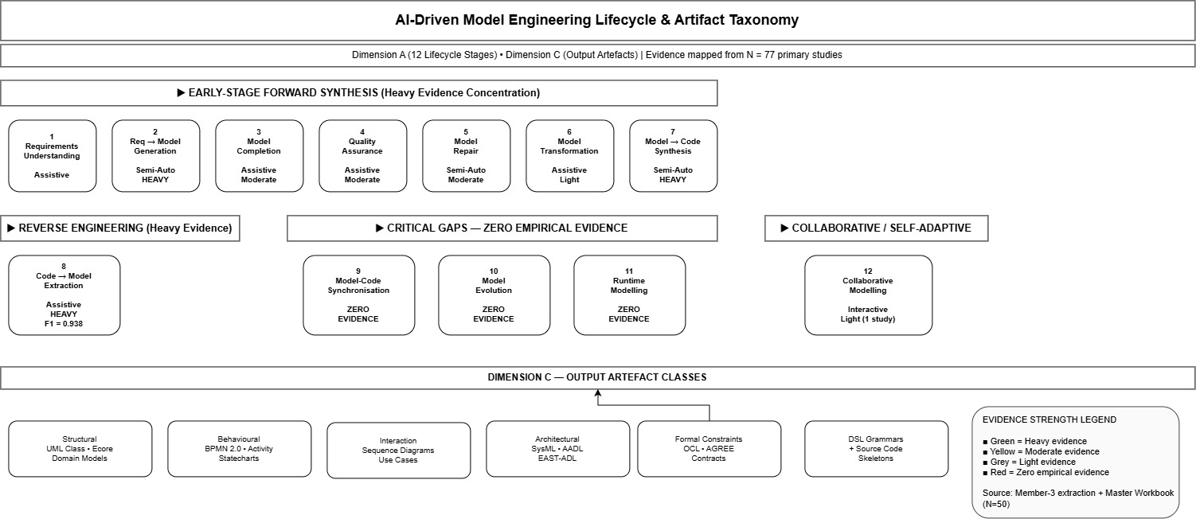
8. References (CPUT Harvard Format)
Ahmed, A., et al. (2026). VeriGen: An LLM-augmented framework for end-to-end automation of software development lifecycle—From requirements specifications to code generation. IEEE Access, 14, 36860–36880. https://doi.org/10.1109/ACCESS.2026.3686308
Ait Hsain, Y., et al. (2025). SCEditor-Web: Bridging model-driven engineering and generative AI for smart contract development. Information, 16(10), 870. https://doi.org/10.3390/info16100870
Alaswad, F., et al. (2026). GenClass: Sequence-to-AST neural machine translation for UML class diagram generation. Machine Learning with Applications, 100940. https://doi.org/10.1016/j.mlwa.2026.100940
Antal, G., Vozár, R., & Ferenc, R. (2024). Assessing GPT-4-Vision's capabilities in UML-based code generation. In Proceedings of the 2024 IEEE/ACM International Conference on Software Engineering: Companion Proceedings (ICSE-Companion '24) (pp. 253–256). ACM. https://doi.org/10.1145/3643795.3648391
Awan, M., et al. (2026). AI-augmented real-time collaborative blended modeling framework for automotive embedded systems. IET Software, 2026(1), Article 6696040. https://doi.org/10.1049/sfw2/6696040
Ben Chaaben, M., Burgueño, L., David, I., & Sahraoui, H. (2026). On the utility of domain modeling assistance with large language models. ACM Transactions on Software Engineering and Methodology (TOSEM), 35(4), Article 112. https://doi.org/10.1145/3744920
Boujmil, I., & Chebil, W. (2025). Improving BPMN model generation from texts through a prompt-guided fusion of NLP and LLM approaches. In Proceedings of the 13th Knowledge Capture Conference (K-CAP '25) (pp. 1–5). ACM. https://doi.org/10.1145/3731443.3771362
Chen, K., Yang, Y., Chen, B., López, J. A. H., Mussbacher, G., & Varró, D. (2023). Automated domain modeling with large language models: A comparative study. In Proceedings of the 26th ACM/IEEE International Conference on Model Driven Engineering Languages and Systems (MODELS '23) (pp. 162–172). IEEE. https://doi.org/10.1109/MODELS58315.2023.00037
Chen, R., Shen, J., & He, X. (2026). MoRe: LLM-based domain model generation with hybrid self-refinement. Electronics (Switzerland), 15(6), Article 1239. https://doi.org/10.3390/electronics15061239
De Bari, D., Garaccione, G., Coppola, R., Torchiano, M., & Ardito, L. (2024). Evaluating large language models in exercises of UML class diagram modeling. In Proceedings of the 18th ACM/IEEE International Symposium on Empirical Software Engineering and Measurement (ESEM '24) (pp. 101–112). ACM. https://doi.org/10.1145/3674805.3690741
Delgado, D., et al. (2026). A modular framework for assessing the capabilities of code generation of constraint domain-specific languages with large language models. Journal of Systems and Software, 238, Article 112871. https://doi.org/10.1016/j.jss.2026.112871
Di Rocco, J., Di Ruscio, D., Di Sipio, C., Nguyen, P. T., & Pierantonio, A. (2023). MemoRec: A recommender system for assisting modelers in specifying metamodels. Software and Systems Modeling, 22(3), 994–1012. https://doi.org/10.1007/s10270-022-00994-2
Karlsson Landgren, A., Johnsen, P. P., & Strüber, D. (2025). Cross-platform edge deployment of machine learning models: A model-driven approach. Software and Systems Modeling, 24(2), 1273–1290. https://doi.org/10.1007/s10270-025-01273-6
Miranda, J. P., Bruneliere, H., Tisi, M., & Sunye, G. (2024). Towards the integration support for machine learning of inter-model relations in model views. In Proceedings of the 39th ACM/SIGAPP Symposium on Applied Computing (SAC '24) (pp. 360–368). ACM. https://doi.org/10.1145/3605098.3636143
Morales, S., Clarisó, R., & Cabot, J. (2025). Impromptu: A framework for model-driven prompt engineering. Software and Systems Modeling, 24(4), 1627–1645. https://doi.org/10.1007/s10270-024-01235-4
Siala, H. A. (2024). Enhancing model-driven reverse engineering using machine learning. In Proceedings of the 46th International Conference on Software Engineering: Companion Proceedings (ICSE-Companion '24) (pp. 46–50). ACM. https://doi.org/10.1145/3639478.3639797
Siala, H. A., & Lano, K. (2025). Using large language models to extract UML class diagrams from Java programs. In Proceedings of the 2025 IEEE International Conference on Software Science and Engineering (ICoSSE '25) (pp. 20–27). IEEE. https://doi.org/10.1109/ICoSSE65712.2025.00020
Siala, H. A., & Lano, K. (2026). Leveraging LLMs for abstracting UML and OCL representations from Java and Python programs. Journal of Systems and Software, 238, Article 112874. https://doi.org/10.1016/j.jss.2026.112874
Tahat, A., Amundson, I., Hardin, D., & Cofer, D. (2026). AGREE-Dog Copilot: A neuro-symbolic approach to enhanced model-based systems engineering. In B. Steffen (Ed.), Bridging the Gap Between AI and Reality (AISoLA 2025, LNCS Vol. 16220, pp. 112–131). Springer. https://doi.org/10.1007/978-3-032-07132-3_8
Tsampouris, G., et al. (2025). RQ2DSL: An AI agent for automated domain-specific language grammar generation from requirements. In Proceedings of the 37th IEEE International Conference on Tools with Artificial Intelligence (ICTAI '25) (pp. 189–196). IEEE. https://doi.org/10.1109/ICTAI66417.2025.00189
Wang, C., Wang, B., Liang, P., & Liang, J. (2024). Assessing UML diagrams by GPT: Implications for education. Applied Sciences (Switzerland), 14(23), Article 10873. https://doi.org/10.3390/app142310873

